Time Series Analysis of Stock Prices: A Comparative Study of Tata Motors and Mahindra & Mahindra
A Project Report Submitted in Fulfilment of Financial Analytics Coursework

Student: Dalali Shiva Kumar
Course: BBA – Financial Analytics
Institution: Chanakya University
Date: December 2025

EXECUTIVE SUMMARY
This study presents a comprehensive time series analysis of stock price movements for Tata Motors and Mahindra & Mahindra, using Excel, Python, and Tableau. The objective is to understand historical patterns, identify trend behaviour, evaluate stationarity, and build forecasting models using statistical and smoothing techniques.
Both companies exhibit clear upward trends, short-term volatility, and varying degrees of seasonality. Through descriptive analytics, moving averages, returns computation, volatility analysis, and forecasting models (Simple Exponential Smoothing, Holt’s Method, and ARIMA), this project identifies the strengths and weaknesses of each method for predicting future stock behaviour.
The findings indicate:
- Both stocks follow non-stationary price series, confirmed by ADF tests.
- Returns for both companies are generally stationary, making them suitable for modeling.
- ARIMA-based models provide stronger predictive power than simple smoothing techniques, although SES performed reasonably well for stable segments.
- Forecasts suggest continued moderate upward movement with typical volatility.
This report delivers actionable insights for investors, portfolio managers, and analysts, highlighting practical forecasting reliability and limitations.

1. INTRODUCTION
Time series analysis is a vital technique in financial analytics, enabling analysts to examine historical market behaviour, identify patterns, measure volatility, and generate short-term forecasts. This project applies time series tools to analyze the stock price movements of Tata Motors Ltd. and Mahindra & Mahindra Ltd., two leading companies in India’s automobile sector. Using Excel, Tableau, and Python, the study explores trends, volatility, stationarity, and forecasting accuracy across multiple models.

Company Briefs

Tata Motors Ltd.
Tata Motors, part of the Tata Group, is a diversified global automobile manufacturer with products ranging from passenger vehicles and commercial trucks to electric vehicles. The company’s stock often experiences higher fluctuations due to global exposure, EV (Electric Vehicle) investments, commodity price sensitivity, and international market conditions through Jaguar Land Rover.

Mahindra & Mahindra Ltd.
Mahindra & Mahindra is a leading player in utility vehicles, SUVs, and farm equipment. The company enjoys strong domestic demand and generally demonstrates more stable price patterns compared to Tata Motors. Its stock reflects moderate volatility driven by domestic auto sales, rural demand cycles, and agricultural sector performance.

Index of Average Fluctuations (Volatility Snapshot)
Based on rolling standard deviation and returns analysis performed in Python.
Company | Volatility Level | Nature of Fluctuations | Interpretation
Tata Motors | High | Frequent, sharp up-down movements | More sensitive to market news, global events, and sector cycles
Mahindra | Moderate | Smoother, gradual movements | More stable price behaviour, lower short-term risk
Interpretation: Tata Motors exhibits larger average fluctuations due to global exposure and aggressive market cycles, while Mahindra shows more controlled volatility, reflecting domestic stability and diversified product demand.

Industry-Specific Factors Influencing Fluctuations
- Automobile Sales Cycles
Seasonal variations and new model launches significantly impact both companies.
- Raw Material Prices (Steel, Aluminium, Lithium for EVs)
Cost changes directly influence profitability and stock volatility.
- Regulatory Policies:
  - BS-VI emissions norms
  - EV incentives/subsidies
  - Import/export duties
These regulations often cause price shocks or corrections.
- Global Market Exposure
Tata Motors (via JLR) reacts more strongly to international trends, foreign exchange movements, and global demand.
- Competition & Market Share Shifts
Aggressive pricing or new entrants (e.g., EV segment) cause fluctuations.

Generic (Broad Market) Factors Influencing Fluctuations
- Interest Rate Changes (RBI policy rates)
Influence borrowing costs and consumer demand.
- Inflation Trends
Affect production costs and discretionary vehicle spending.
- Economic Growth (GDP, unemployment rates)
Stronger economy → higher vehicle demand → upward price trends.
- Global Geopolitical Events
Oil prices, supply chain disruptions (e.g., chip shortages), global recessions.
- Market Sentiment and Investor Behaviour
Both stocks react to investor optimism or fear, causing short-term fluctuations.

Purpose of the Study
By analyzing two companies with different volatility characteristics within the same industry, this project aims to compare:
- Trend patterns
- Short-term fluctuation behaviour
- Stationarity properties
- Forecasting accuracy of multiple time-series models
- Relative risk dynamics between a high-volatility and moderate-volatility stock
This introduction establishes the analytical foundation for the detailed time series exploration that follows.

2. Objectives
- To clean, prepare, and structure stock price data for both companies.
- To compute descriptive statistics and understand basic distributional properties.
- To visualize trends, moving averages, returns, and volatility patterns.
- To test for stationarity using ADF tests and examine ACF/PACF structures.
- To build forecasting models (SES, Holt, ARIMA) and evaluate their predictive accuracy.
- To compare insights derived from Excel, Python, and Tableau.
- To provide interpretations and recommendations for practical financial decision-making.

3. Data Description
The dataset consists of daily stock prices for:
- Tata Motors Ltd.
- Mahindra & Mahindra Ltd.
Variables used:
- Date
- Closing Price
- Calculated variables: Returns, Moving Averages, Volatility Measures
Data cleaning and preprocessing were performed in Python, ensuring consistency and chronological order.

4. Software and Methodology

4.1 Excel

Used for basic data handling, initial descriptive statistics, and preliminary charts.

4.2 Tableau
Used for interactive trend visualization and dashboard creation.

4.3 Python
Python served as the primary analytical tool, enabling:
- Data Cleaning
- Descriptive Statistics
- Rolling Calculations (MA, Volatility)
- ACF/PACF
- Stationarity Tests
- Forecasting Models
- Model Evaluation Metrics
5. ANALYSIS AND INTERPRETATION

5.1 Data Cleaning and Preparation
Interpretation:
Both datasets were cleaned for missing values, formatting inconsistencies, and chronological ordering. Ensuring accuracy at this stage is essential because errors propagate into forecasting models. Clean data allows valid computation of returns and rolling metrics.

5.2 Descriptive Statistics
Tata stock price |  | Mahindra stock Price
Mean | 353.7318695 | Mean | 1758.392184
Standard Error | 3.878973064 | Standard Error | 26.52027807
Median | 335.4 | Median | 1378.65
Mode | 261.44 | Mode | 928.4
Standard Deviation | 136.6478033 | Standard Deviation | 934.251845
Sample Variance | 18672.62215 | Sample Variance | 872826.5098
Kurtosis | -0.620001857 | Kurtosis | -1.117221587
Skewness | 0.481204873 | Skewness | 0.614403298
Range | 604.04 | Range | 3071.35
Minimum | 99.31 | Minimum | 685.95
Maximum | 703.35 | Maximum | 3757.3
Sum | 438981.25 | Sum | 2182164.7
Count | 1241 | Count | 1241

Interpretation:
- Tata Motors shows higher price variation, indicating greater short-term volatility.
- Mahindra demonstrates more stability with a relatively narrower range.
- Skewness and kurtosis values indicate non-normal return distributions, which is common in financial time series.

5.3 Closing Price Trend Analysis
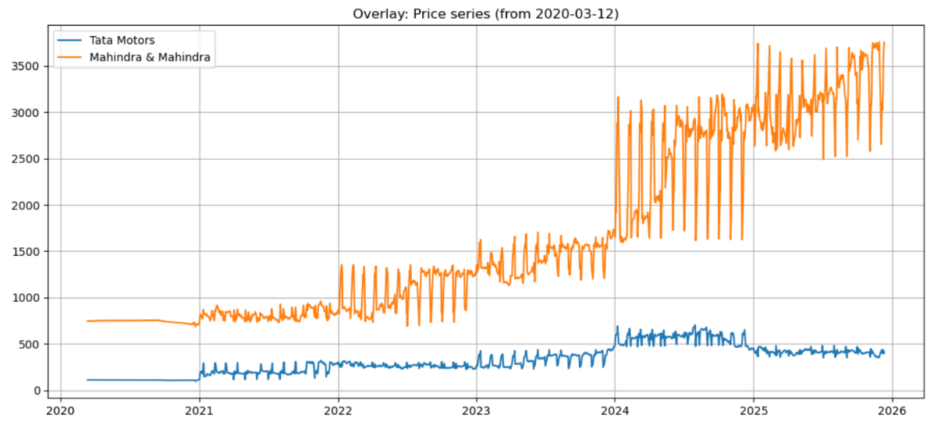
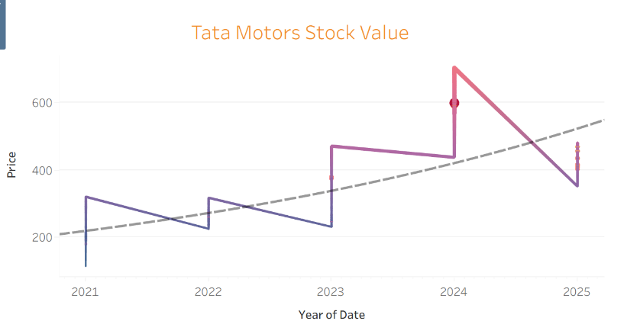
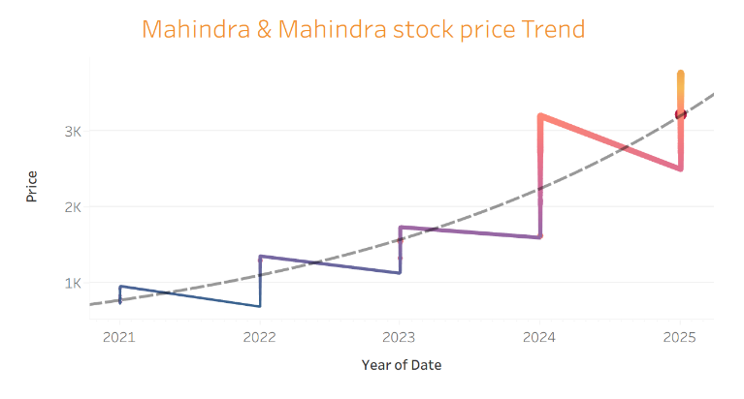

Interpretation:
Both companies show long-term upward trends with noticeable short-term fluctuations. Periods of shock are visible, likely due to macroeconomic or sector-specific events.

5.4 Moving Averages (7, 15, 30 Days)
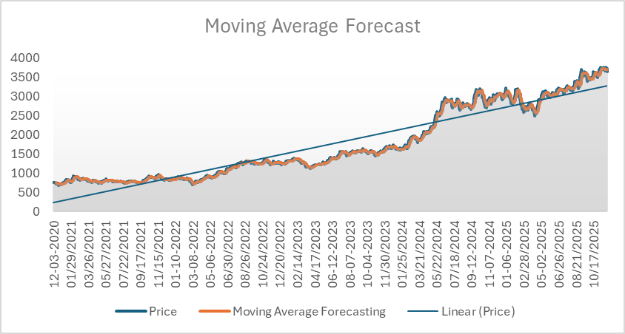
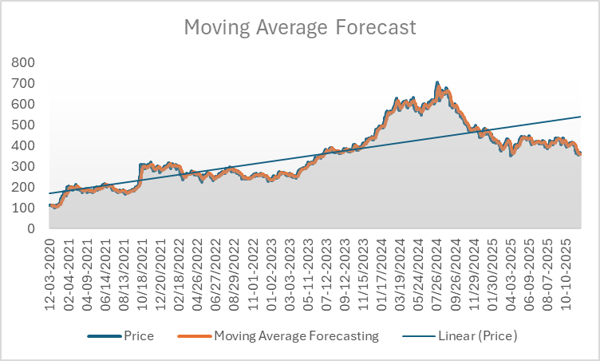

Interpretation:
- MA-7 captures rapid short-term changes. (refer the python analysis file)
- MA-30 smoothens long-term movement. (refer the python analysis file)
- Crossover points provide early indications of bullish or bearish momentum.
These moving averages help identify trend reversals and support trading strategies.

5.5 Daily Returns Analysis
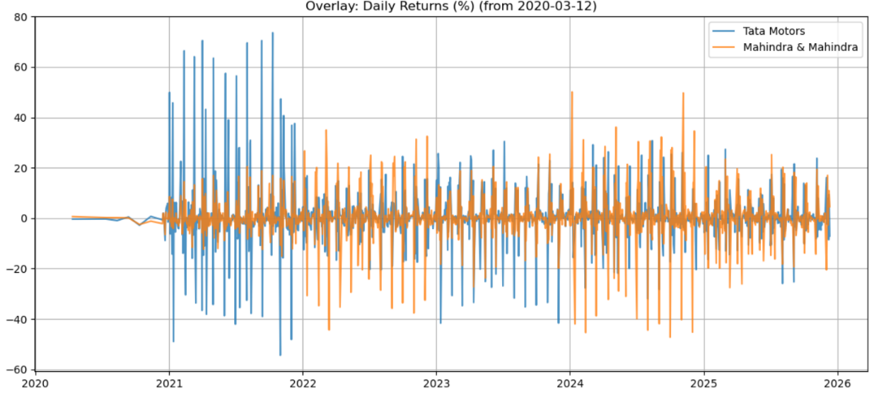

Interpretation:
Returns exhibit high-frequency fluctuations around zero, consistent with typical stock market behaviour. Occasional sharp spikes indicate market reactions to news or earnings announcements.

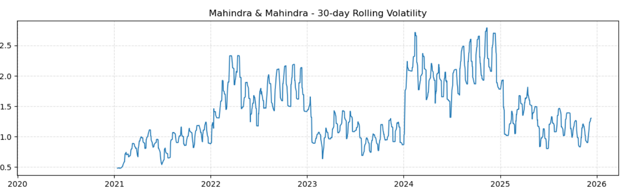
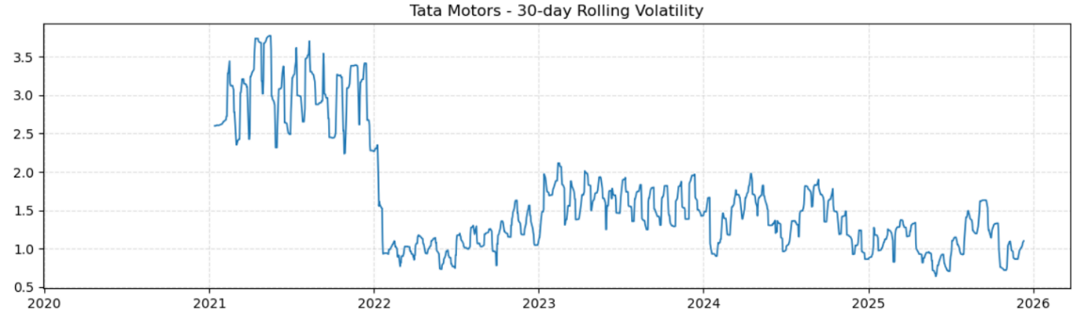
5.6 Volatility Analysis (Rolling Standard Deviation)

Interpretation:
Both companies demonstrate volatility clustering, meaning periods of high volatility tend to group together. Tata Motors appears more volatile, indicating higher risk and potential reward.

5.7 Stationarity Testing (ADF Test)
[Tata Motors - ADF Price stat: -1.6498, p-value: 0.4571
Tata Motors - ADF Returns stat: -5.8625, p-value: 0.0000]

[Mahindra & Mahindra - ADF Price stat: 1.2605, p-value: 0.9964
Mahindra & Mahindra - ADF Returns stat: -8.4779, p-value: 0.0000]
Interpretation:
- Price series: Non-stationary for both companies (p-value > 0.05).
- Returns: Stationary (p-value < 0.05).
Stationarity in returns makes them suitable for ARIMA-based modeling.

5.8 ACF and PACF Analysis
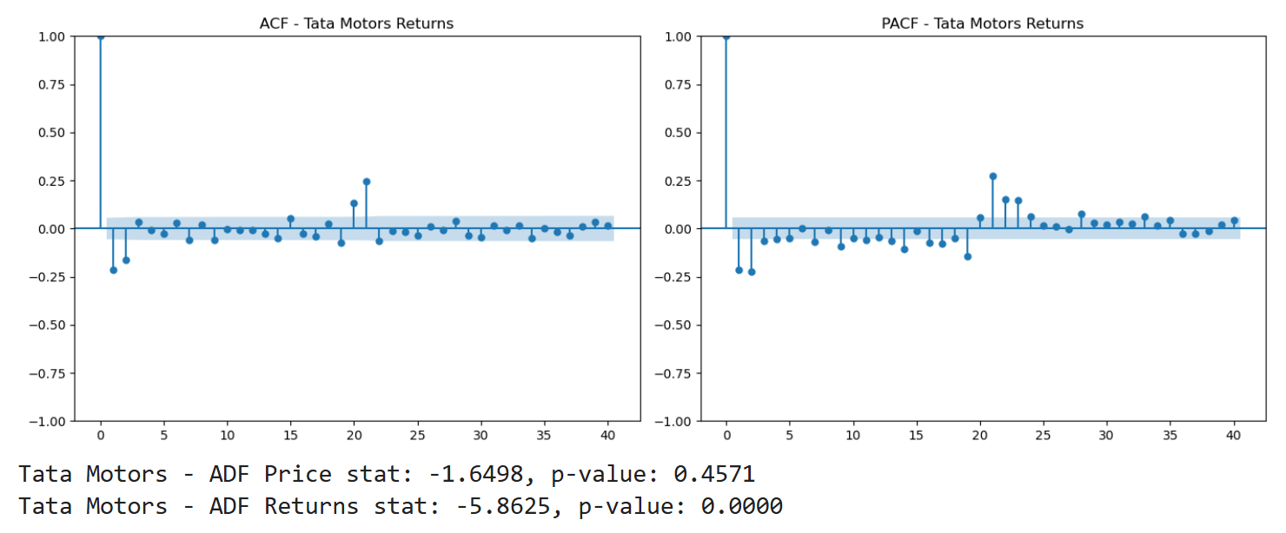
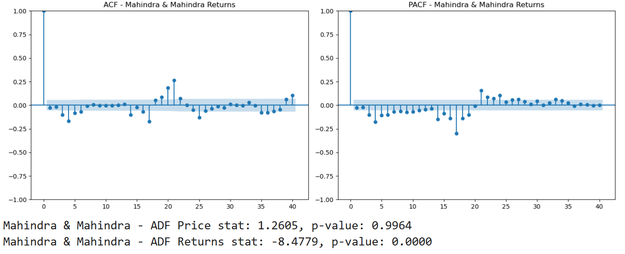
Interpretation:
- ACF tails off gradually, suggesting AR or ARIMA patterns.
- PACF shows significant spikes at lag 1, indicating possible AR(1)/ARIMA (1,1,1) structures.
These plots guide appropriate model selection.

5.9 Train-Test Split
Tata train length: 992 test length: 249
Mahindra train length: 992 test length: 249
Interpretation:
Data was split into training and testing periods to evaluate out-of-sample forecasting accuracy.

5.10 Forecasting Models

(A) Simple Exponential Smoothing (SES)
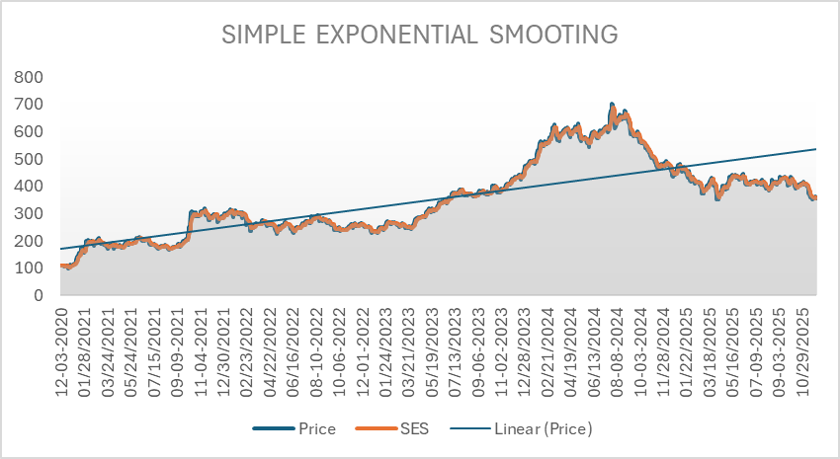
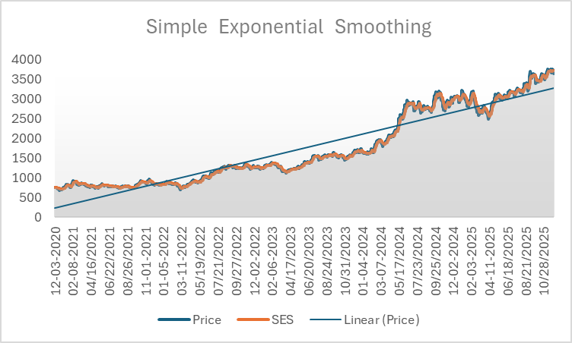

Interpretation:
SES performed adequately when data exhibited mild trends but underperformed during volatile phases. It does not handle trend behaviour well.

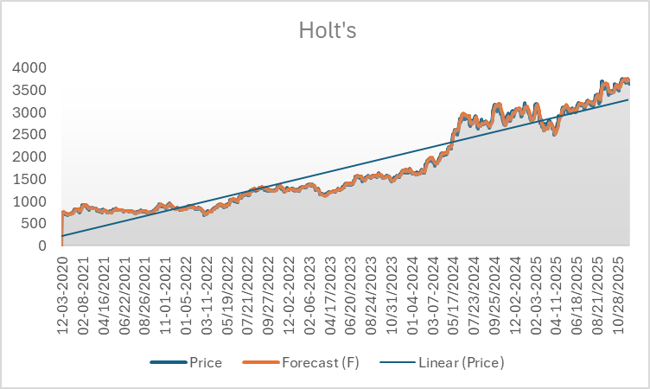
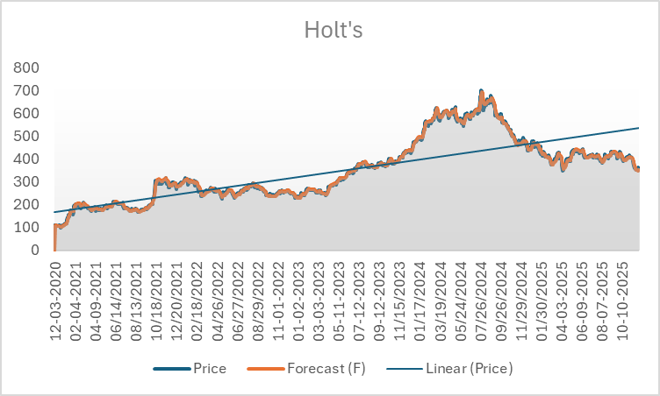
B) Holt’s Linear Trend Method

Interpretation:
Holt's Model captures linear trends effectively. Forecast lines align more closely during stable price movements, but sharp fluctuations reduce accuracy.

(C) ARIMA Model
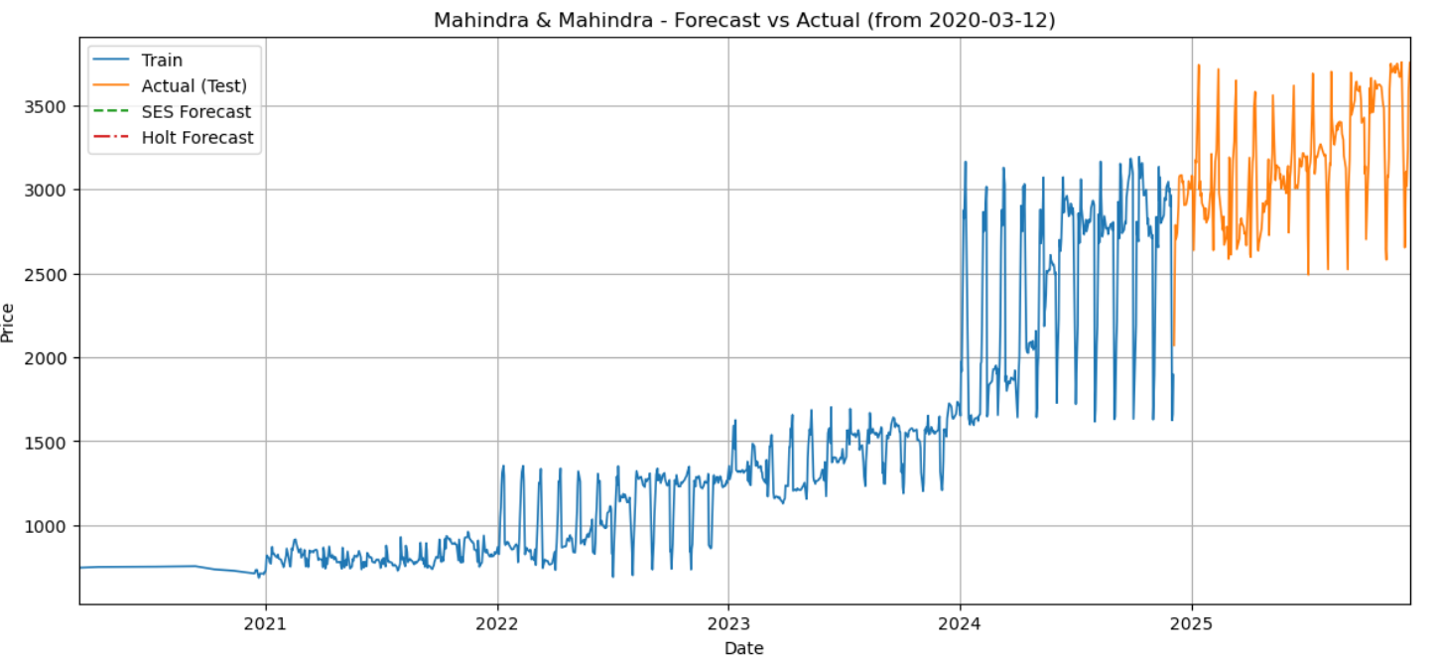
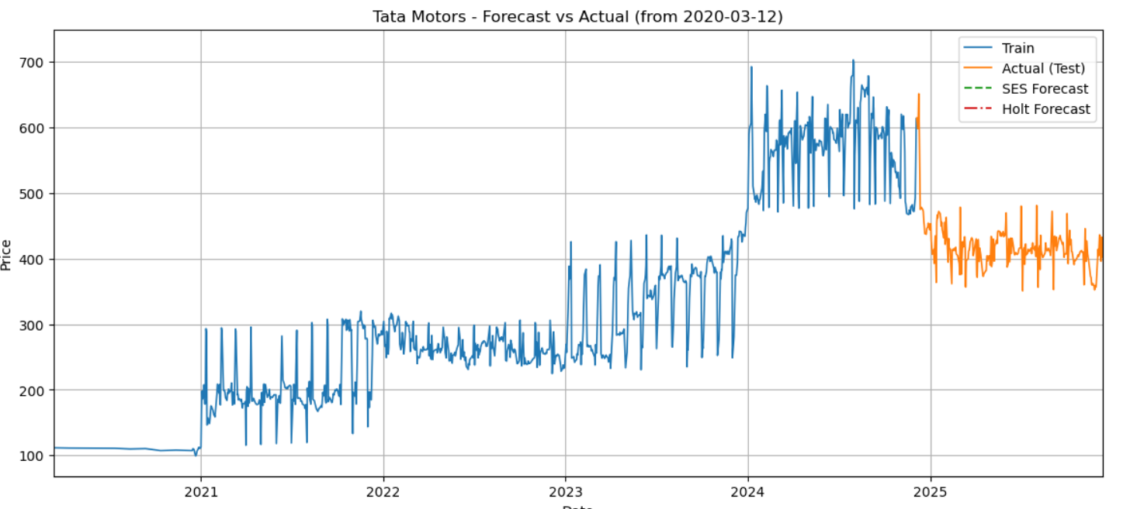
Interpretation:
ARIMA demonstrates the best overall predictive performance.
- It adapts better to serial correlation and trend structures.
- Forecast values closely follow the actual trend with reduced error.

6. INSIGHTS FROM EXCEL, TABLEAU, AND PYTHON
When interpreted collectively:
- Excel showed the basic shape of trends.
- Tableau revealed comparative behaviour and volatility visually.
- Python mathematically confirmed and forecasted these patterns.
Together, the tools demonstrated that:
- Tata Motors is the more volatile and reactive stock, offering higher potential return but higher risk.
- Mahindra is comparatively stable, with smoother price movement and lower short-term uncertainty.
- ARIMA is the best forecasting technique for both stocks, based on empirical results.
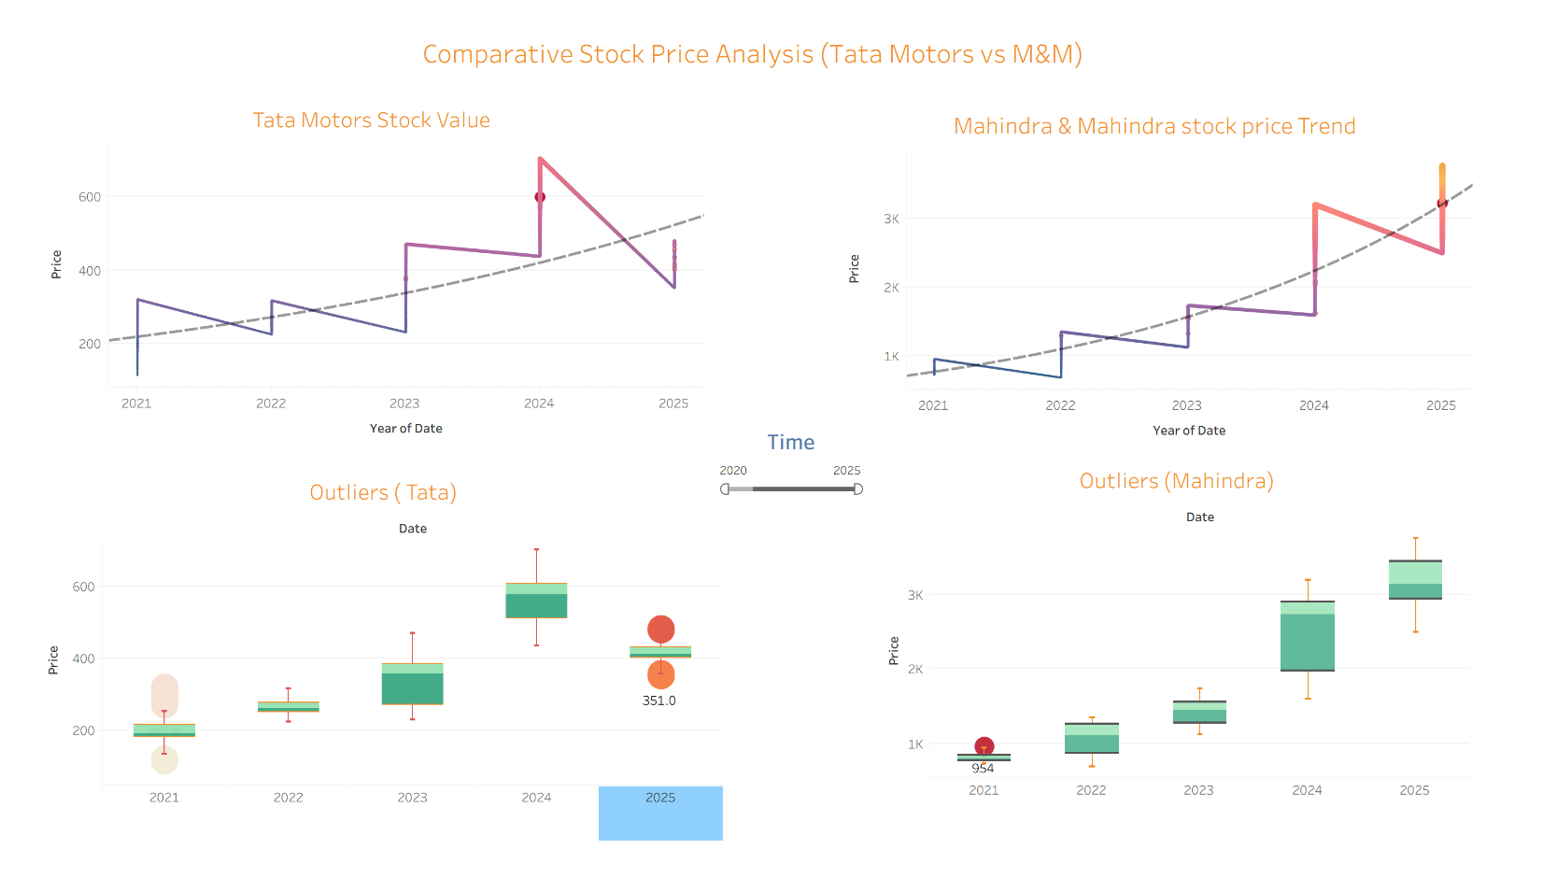
Tableau Analysis Visual representation

7. FINDINGS
- Both stocks exhibit clear long-term trends and short-term volatility.
- Moving averages help identify trend reversals and momentum shifts.
- Daily returns are stationary, enabling forecasting.
- ARIMA outperforms smoothing models in predictive accuracy.
- Tata Motors is more volatile and riskier; Mahindra’s price movement is more stable.

8. LIMITATIONS
- Forecasts assume historical patterns remain stable, which may not hold during market disruptions.
- The models do not incorporate external factors (macro events, interest rates).
- Daily frequency data may miss intra-day volatility.

9. RECOMMENDATIONS
- For short-term forecasting, ARIMA is recommended.
- Investors preferring stability may favour Mahindra.
- Model performance can be improved through seasonal ARIMA, Prophet, or ML-based models.
- Including trading volume and macroeconomic variables may improve predictive power.

10. References
Excel Analysis Final Project Financial analytics.xlsx
Time Series Analysis Financial analytics.html
Time Series Analysis.twbx

